NAME : SHAH FAISAL

ROLL NO : 23I-0058

SECTION : BSE – 6A

COMPUTER NETWORKS LAB

BSSE SPRING 2026

LAB 02

- Task 1: Network Hardware Exploration (10 Marks)
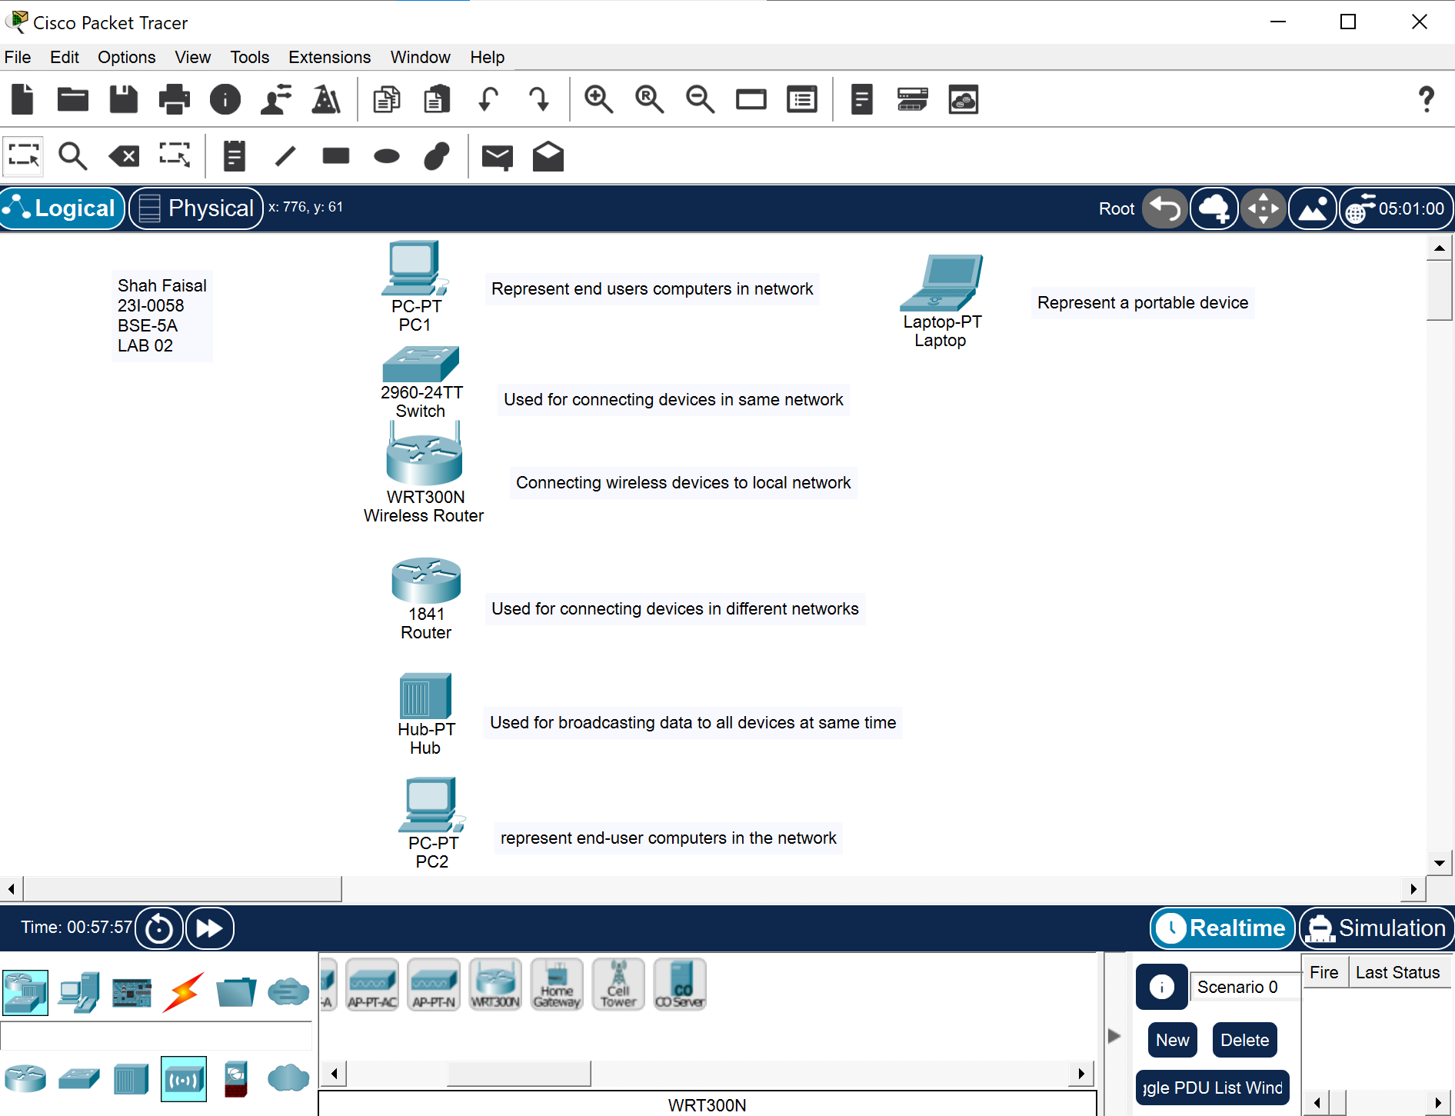
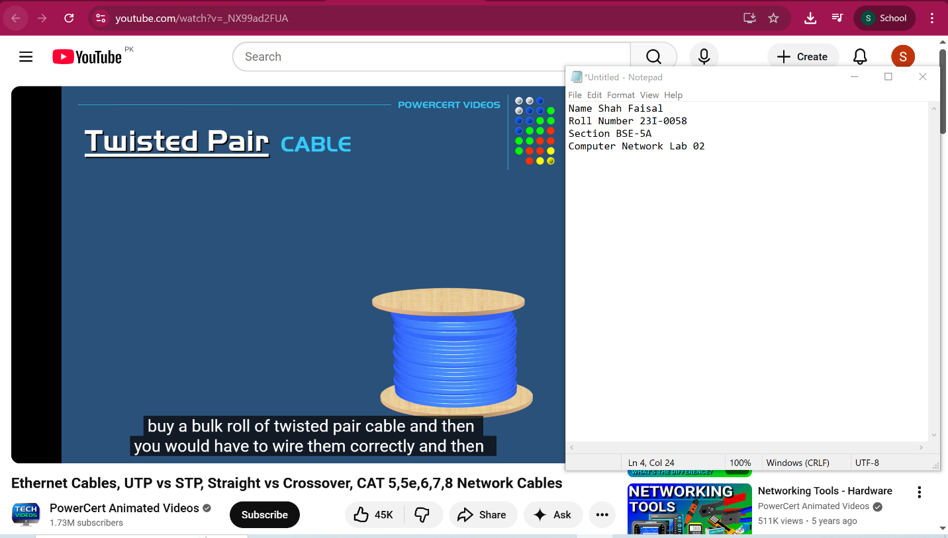
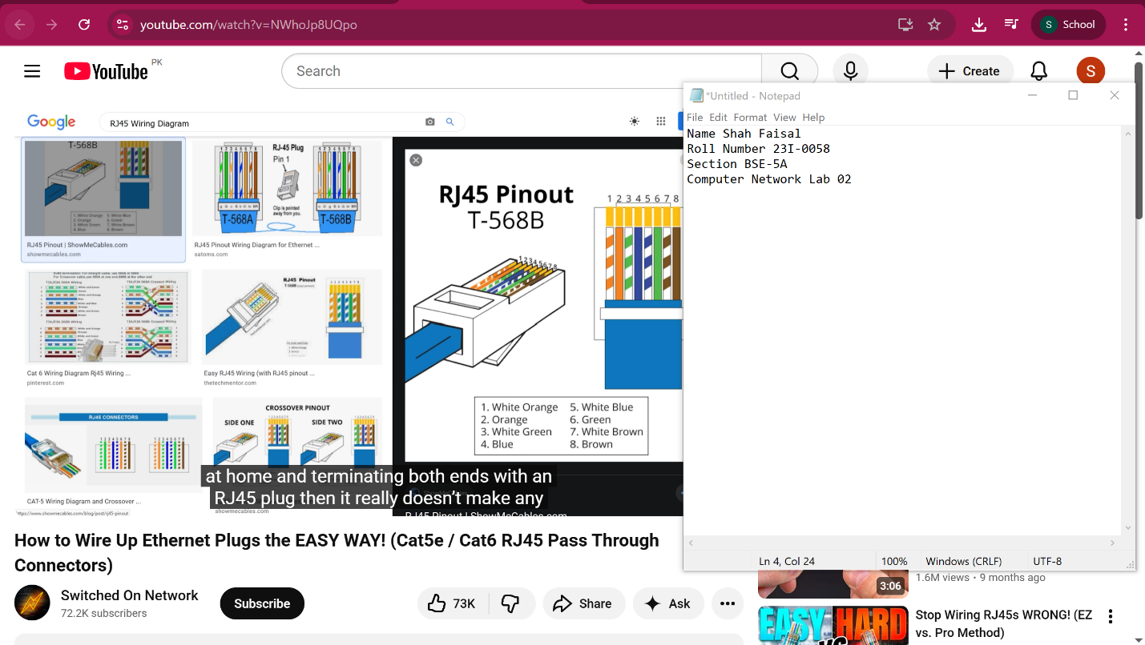

1.What is the function of an RJ45 connector?
An RJ45 connector terminates Ethernet cables and provides a standardized physical interface to connect devices to a network.
2.What is the primary difference between the T568A and T568B wiring standards?
They differ only in the order of the green and orange wire pairs; T568B swaps these pairs compared to T568A.
3.How does the wiring of a "Crossover" cable differ from a "Straight-through" cable?
A straight-through cable uses the same wiring standard on both ends, while a crossover cable uses T568A on one end and T568B on the other.
4.When connecting a computer directly to another computer (without a switch), which cable type should be used?
A crossover cable is used when connecting two computers directly without a switch or hub.
5.List the correct color order for the T568B standard (from pin 1 to 8).
White-Orange, Orange, White-Green, Blue, White-Blue, Green, White-Brown, Brown
Task 2: Create and Simulate Different Network Topologies (10 Marks)
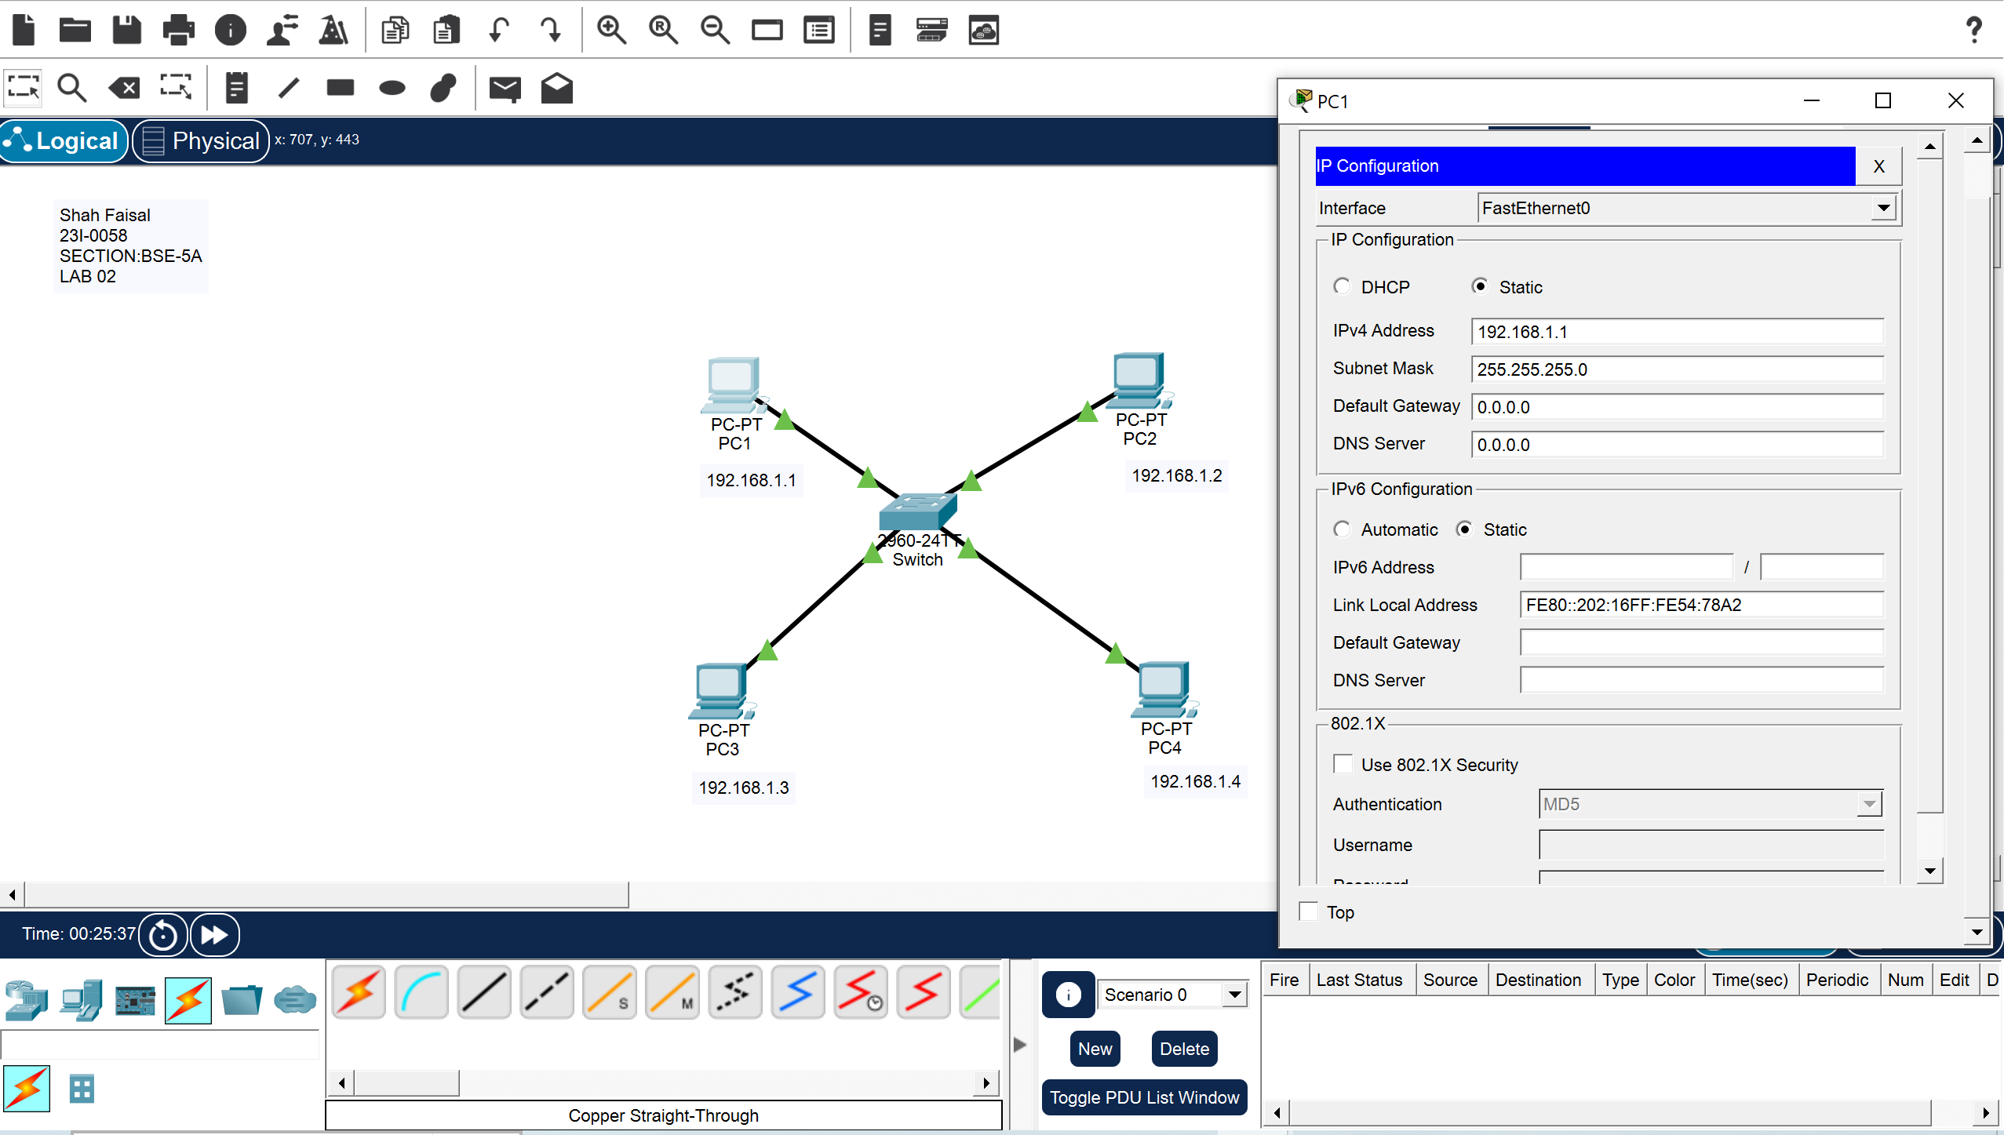
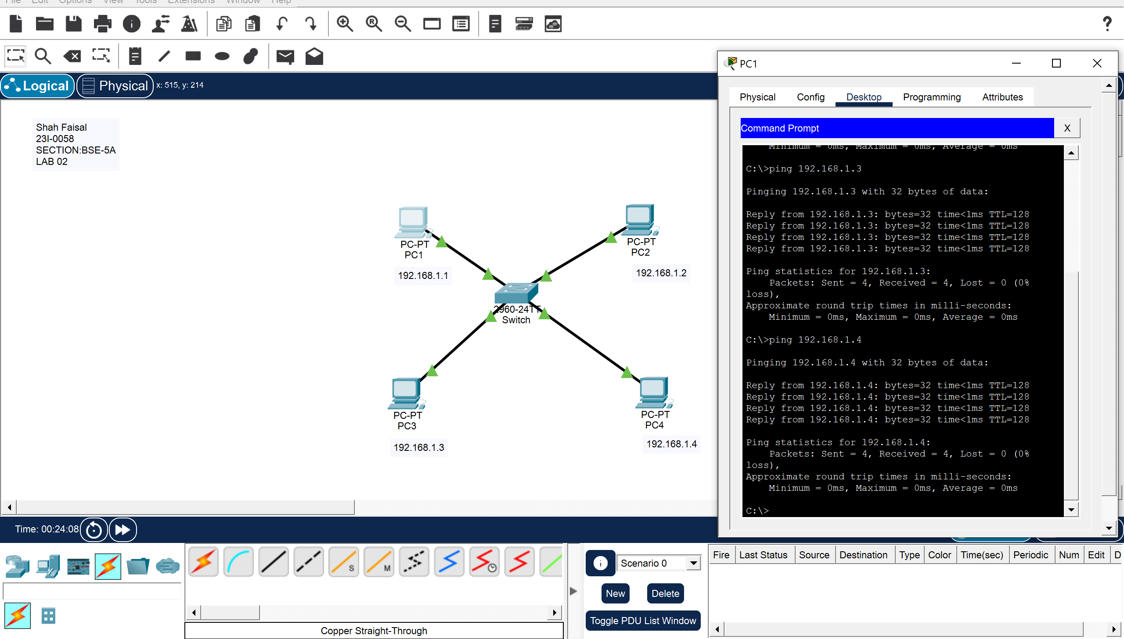

Disadvantage:
The central hub itself becomes a single point of failure; if it fails, the entire network is disrupted.
RING TOPOLOGY
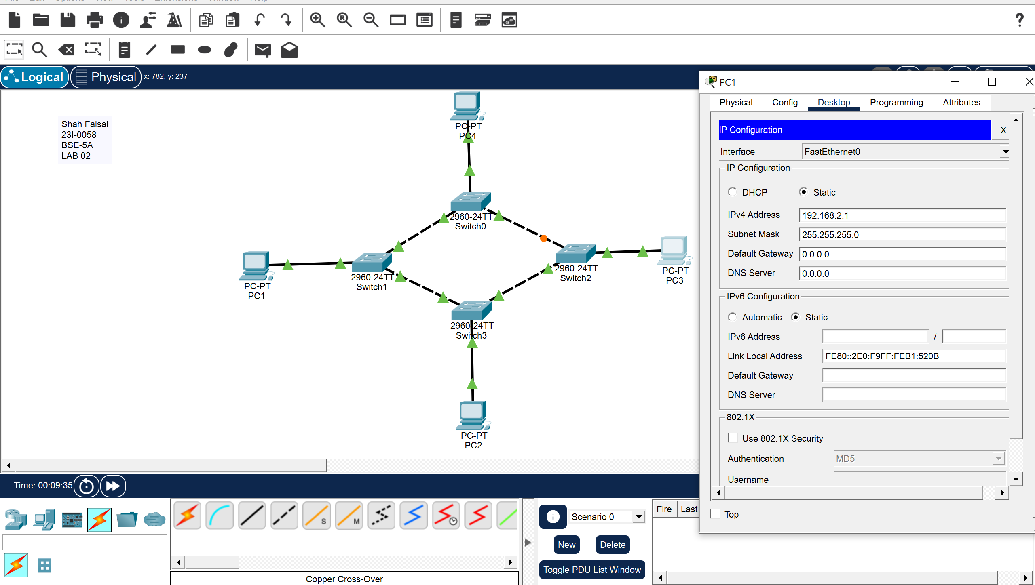
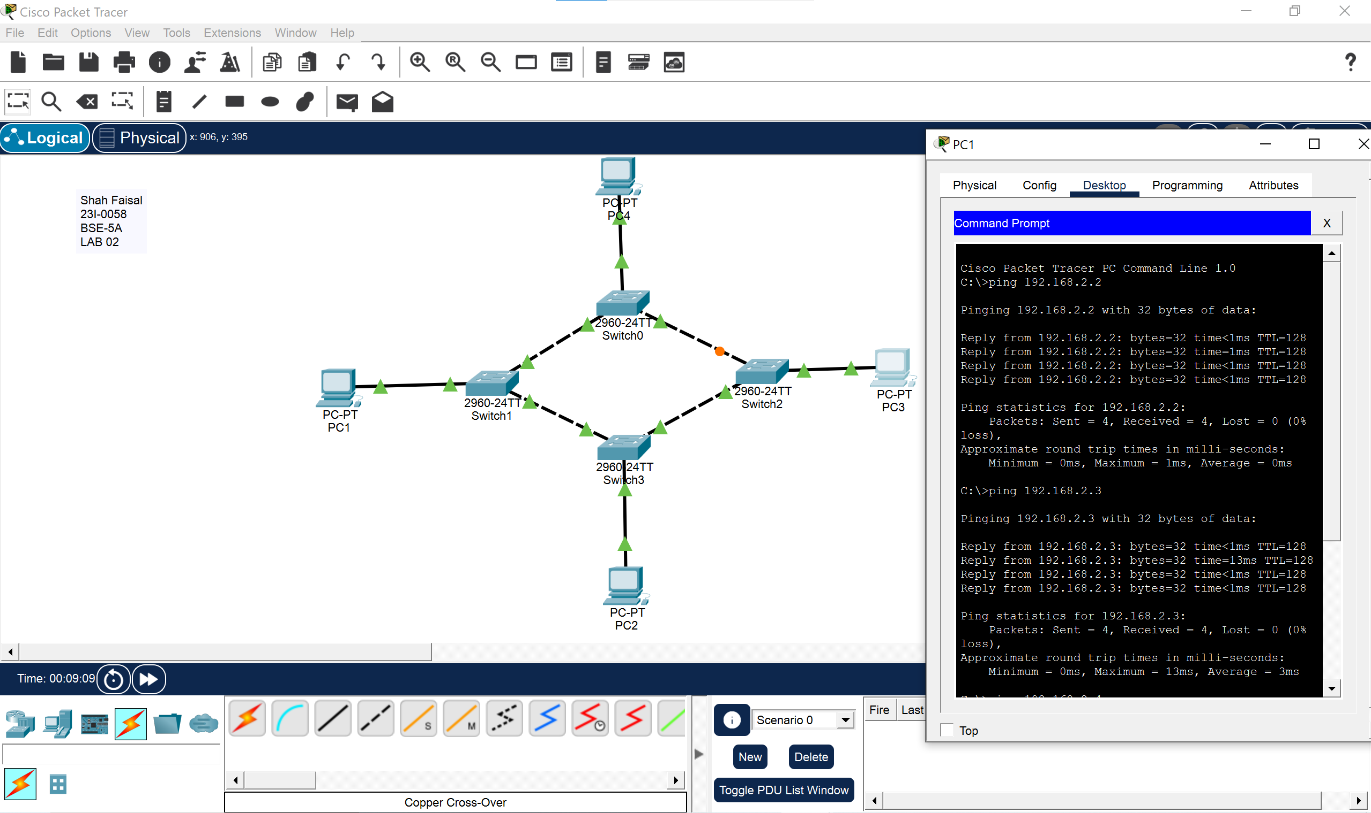
ADVANTAGE:
This topology is relatively simple and prevents data collisions.

BUS TOPOLOGY

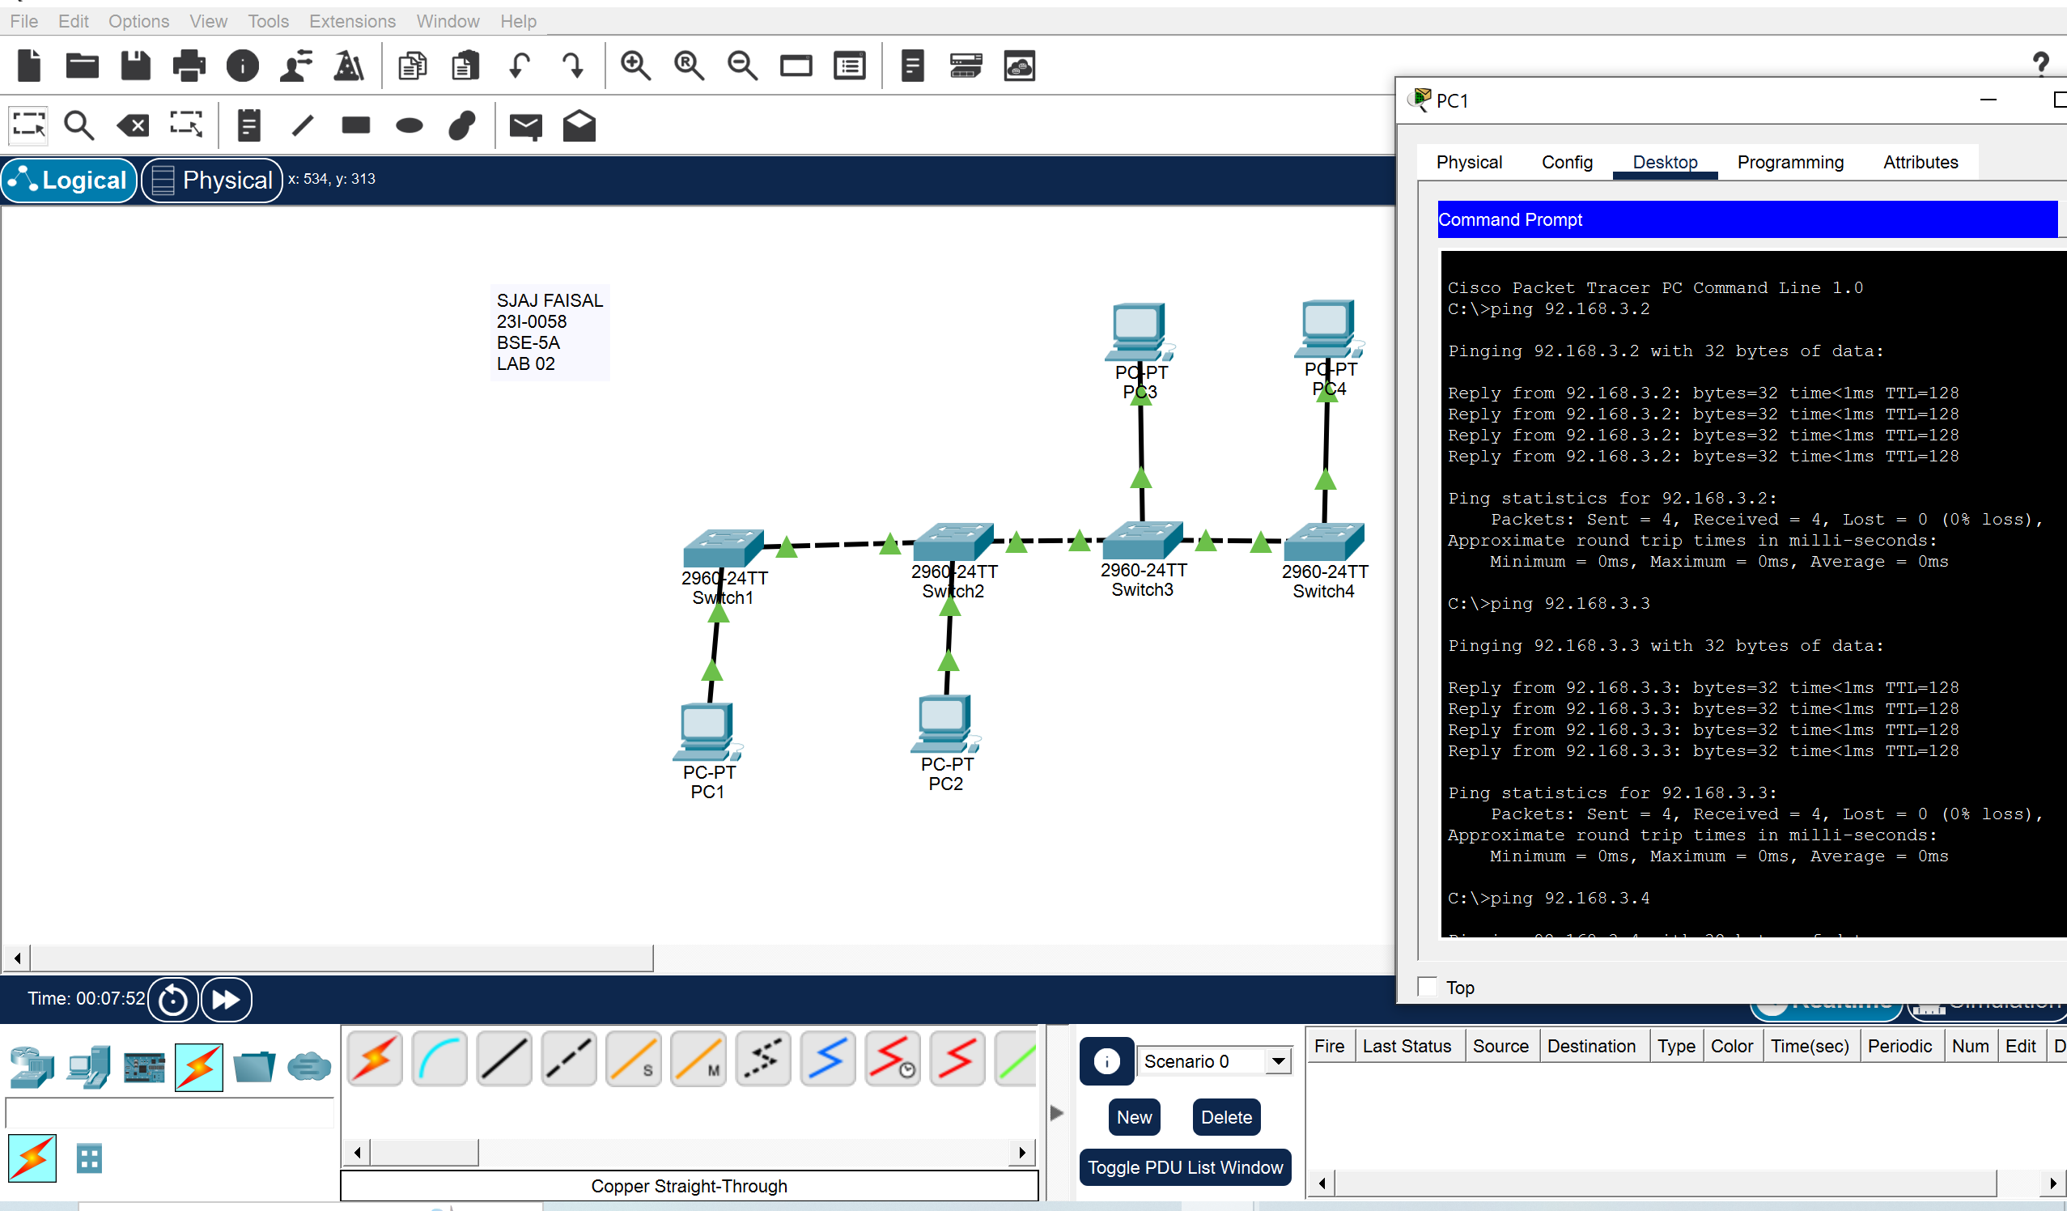
ADVANTAGE:
This topology is cost-effective and simple to implement but is best suited for small networks with limited devices, as performance deteriorates with increased traffic or devices.
MESH TOPLOLOGY:
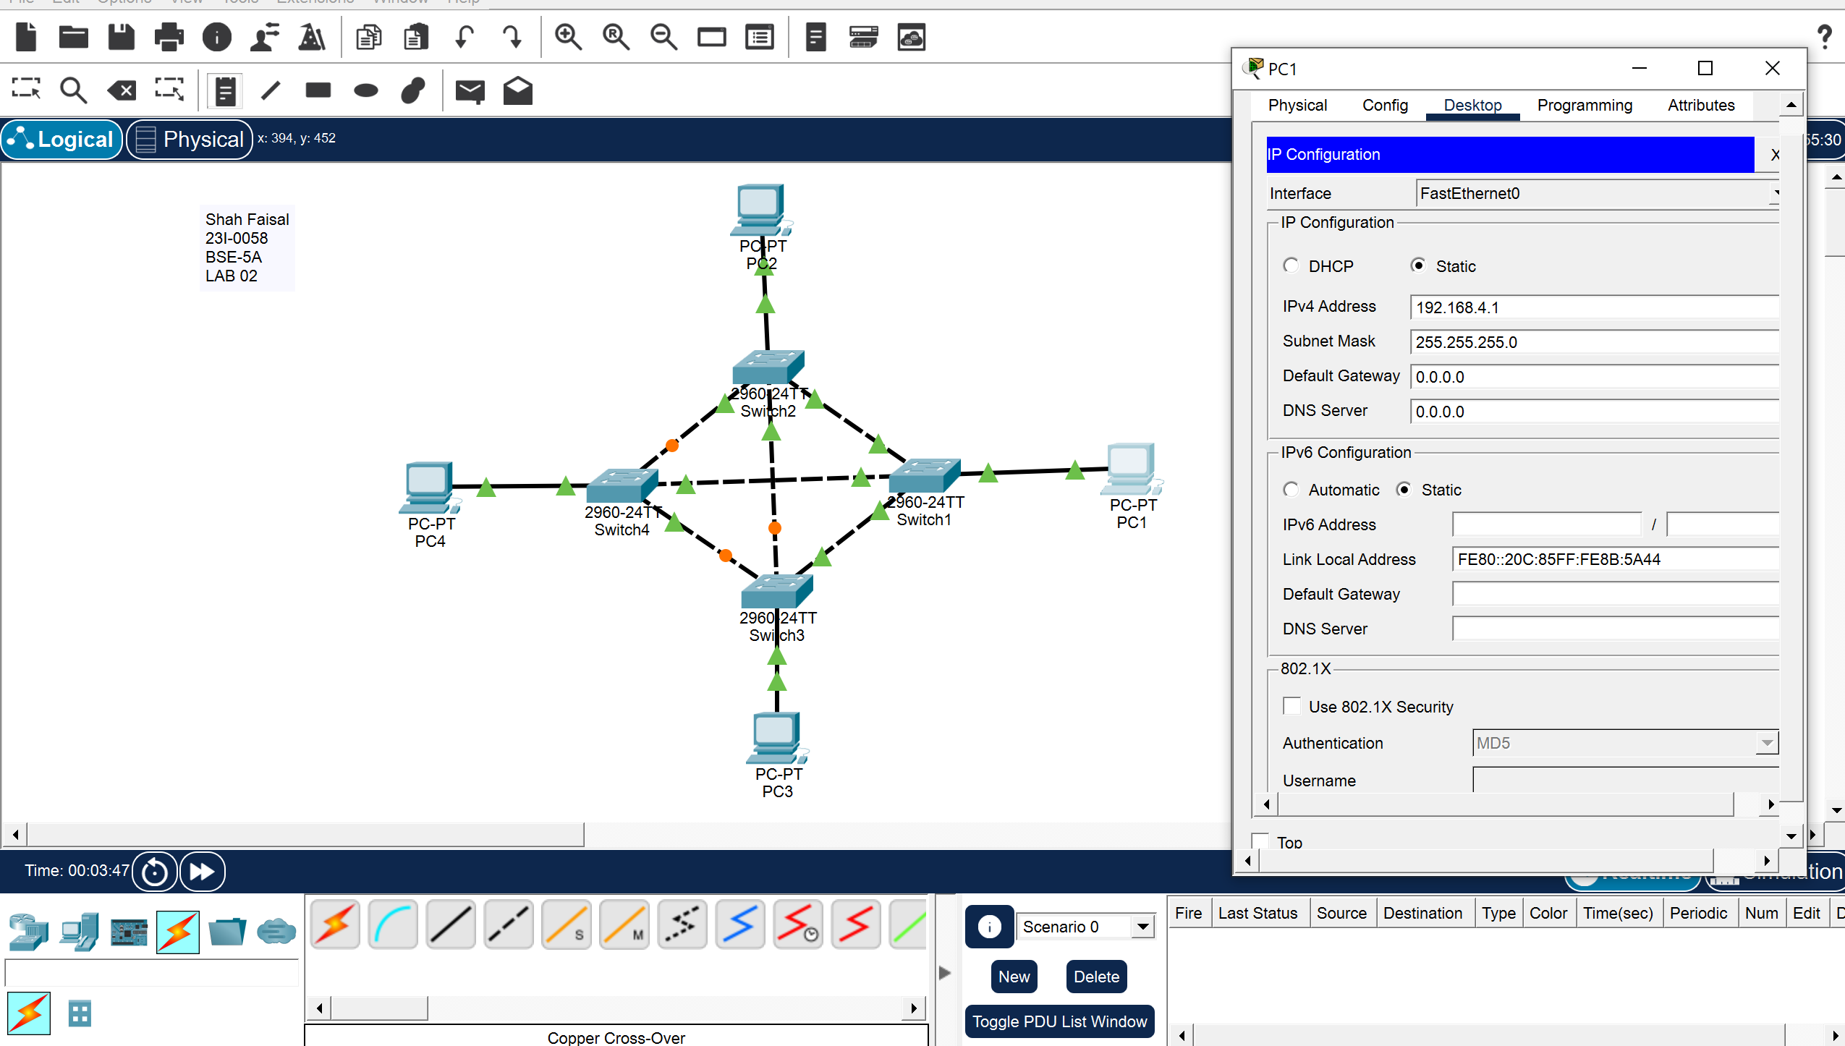

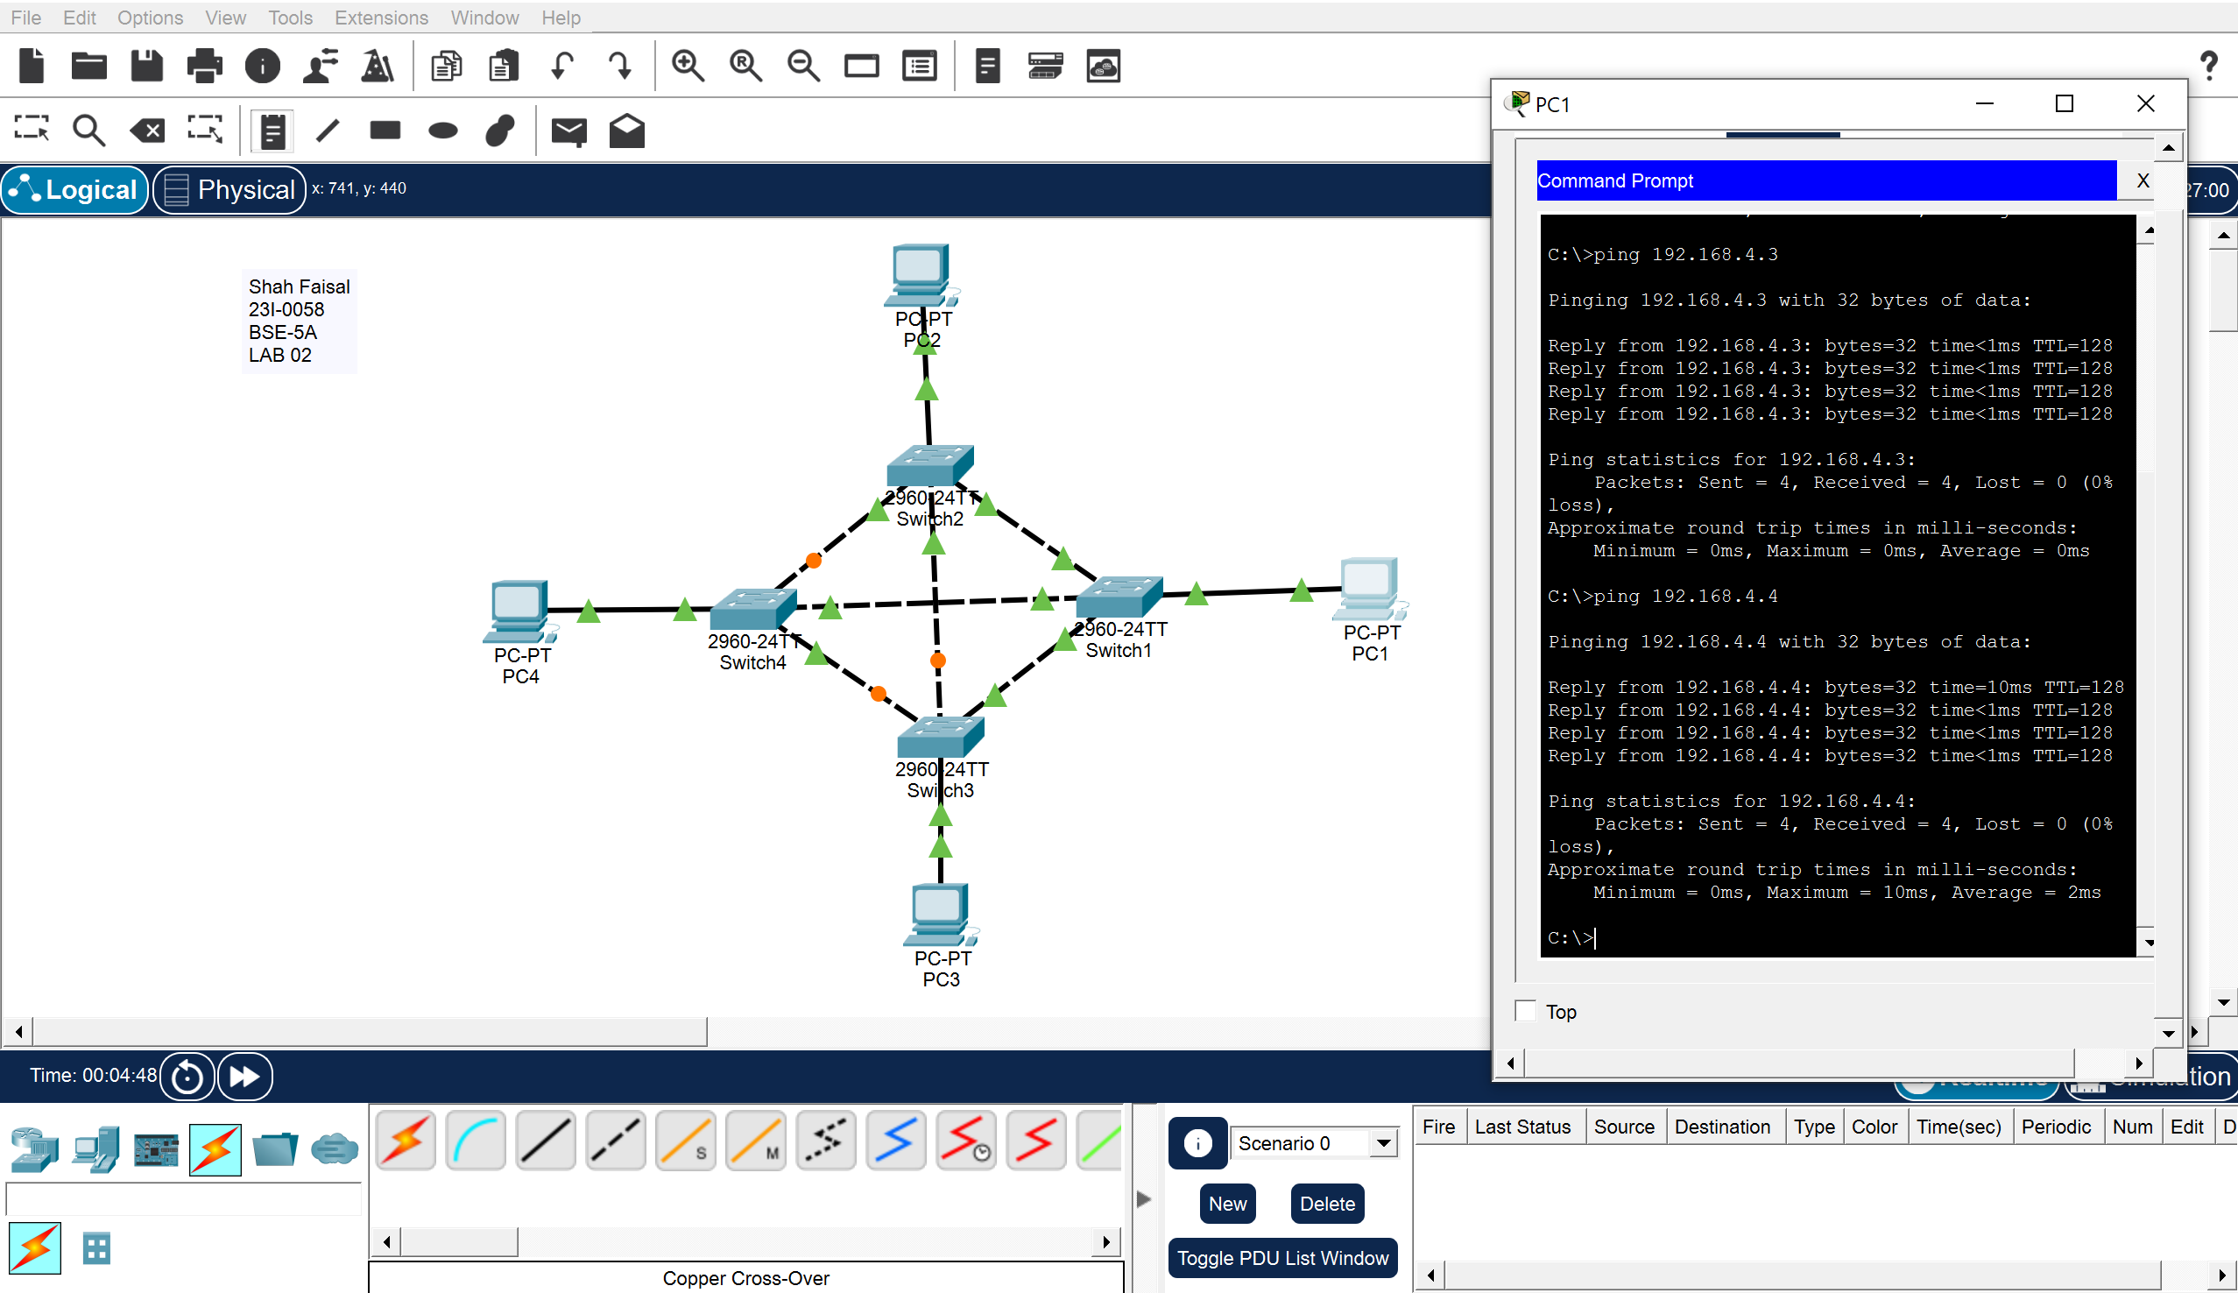

ADVANTAGE:
This ensures high reliability and fault tolerance, as the network remains operational even if one or more links fail.
Task 3: Configure a Wireless Network with 3 PCs (5 Marks)
